# Compass - Member Snapshot Landing Page

Member Snapshot

Case Data

Alerts

Member Details

Client and Processing Information

Center Panel

Quick Actions

Medicare D Quick Actions

Opportunities

Member’s Recent Cases

Medicare D Member Snapshot

Related Documents

**Description:** Outlines the Member Snapshot Landing Page and functionality found in Compass.

|  |
| --- |
| Member Snapshot |

Each panel on the Member Snapshot Landing Page can house individual components that may require scroll bar use. When using the panel scroll bar, scrolling is dynamic. Refer to [Compass - Optimize the On-screen Experience (049985)](https://thesource.cvshealth.com/nuxeo/thesource/#!/view?docid=2f702dca-38c5-4b46-be0b-8191ed5619e1) for more details.

**Note:** For information about the Landing Page for Medicare D members, refer to the Medicare D Member Snapshot section. If the account is not MED D/EGWP, the Medicare D Landing Page and other Medicare D functionality will NOT display.

The Member Snapshot Landing Page contains the following components:

1. Case Data
2. Alerts
3. Member Details
4. Client and Processing Information
5. Center Panel
   * Contact Information
   * Eligibility
   * Mail Order Payments
   * Mail Order Profile
   * ID Cards
   * Statement of Cost
6. Quick Actions
7. Opportunities
8. Member’s Recent Cases

Top of the Document

|  |
| --- |
| Case Data |

The Case Data panel contains the following information collected via the Authentication flow:

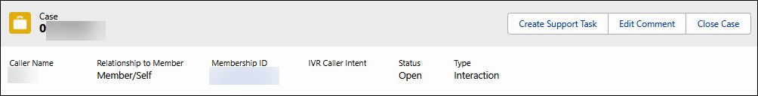

|  |  |
| --- | --- |
| **Section/Field** | **Details** |
| **Case** | Number assigned dynamically. |
| **Caller Name** | Name of the caller. |
| **Relationship to Member** | Indicates relationship to the member. |
| **Membership ID** | Indicates Member’s ID number. |
| **IVR Caller Intent** | Indicates the caller intent selected during the IVR Authentication process, if any selected.  **Note:** May be blank if IVR was unable to determine. |
| **Status** | Indicates the status of the case. |
| **Type** | Indicates the type of case (Interaction or Research). |

Top of the Document

|  |
| --- |
| Alerts |

The Alerts panel contains the following:

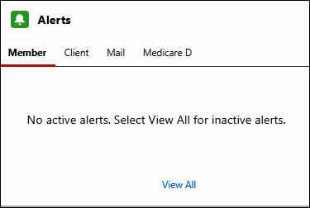

|  |  |
| --- | --- |
| **Section/Field** | **Details** |
| **Member** | Member alert details. |
| **Client** | Client alert details. |
| **Mail** | Mail Order alert details. |
| **Medicare D,** if applicable | Medicare D alert details. |

Top of the Document

|  |
| --- |
| Member Details |

The Member Details panel contains the following:

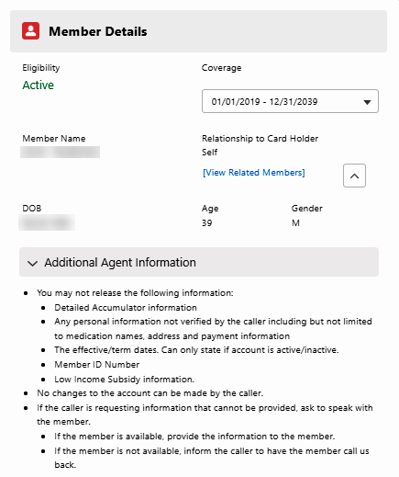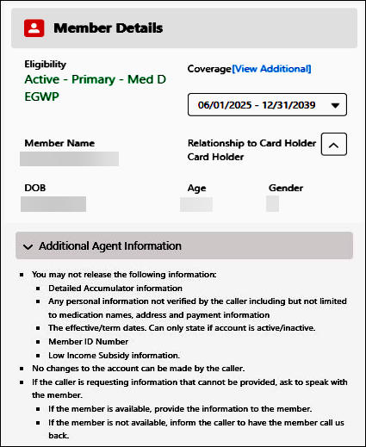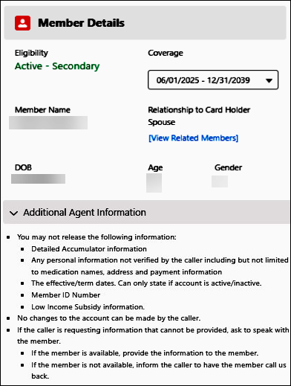

|  |  |
| --- | --- |
| **Section/Field** | **Details** |
| **Eligibility** | * Indicates Active or Inactive. * Medicare related eligibility - displays directly below status, if applicable.   + Primary or Secondary coverage displays for applicable Medicare plans. * Medicare - Dual Demo displays below the status, if applicable. * Cash Card - displays directly below Status if account is a Cash Card.   **Note:** Grace Period displays in green text if the member's account is in a Grace Period. |
| **Coverage** | Indicates the dates of coverage based on the current date. Use the drop-down menu to search for previous, current, or future eligibility periods. |
| **Member Name** | Indicates member’s name. |
| **Relationship to Card Holder** | Indicates relationship to the cardholder.   * Use the drop down to search for family members on the account. A pop-up displays with associated family members on the account.   **Note:** When the user selects the family member hyperlink name from the pop-up, that member’s information will display. |
| **DOB** | Indicates the Eligibility date of birth passed for member record. |
| **Age** | Indicates the member’s age. |
| **Gender** | Indicates the member’s gender as reported by the plan. |
| **Additional Agent Information** | Indicates what information may be released, based on relationship to the member. |

Top of the Document

|  |
| --- |
| Client and Processing Information |

The Client and Processing Information panel contains the following:

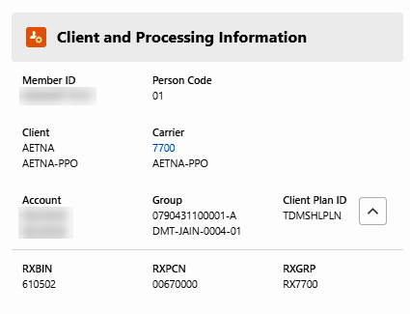

|  |  |
| --- | --- |
| **Section/Field** | **Details** |
| **Member ID** | Indicates member ID found on membership card. |
| **Person Code** | Used for processing, based on the relationship to the cardholder. |
| **Client** | Indicates the client ID and client name. |
| **Carrier** | Indicates Carrier ID (formerly known as Client Code) and number associated with member’s plan. |
| **Account** | Indicates account number and ID associate with member’s plan. |
| **Group** | Indicates group ID and name associated with member’s account. |
| **Client Plan ID** | Indicates the plan name associated with member’s plan. |

Top of the Document

|  |
| --- |
| Center Panel |

The Center Panel contains the following tabs:

* Contact Information
* Eligibility
* Mail Order Payments
* Mail Order Profile
* ID Cards
* Statement of Cost

**Contact Information**

The Contact Information tab contains the following collapsible sections:

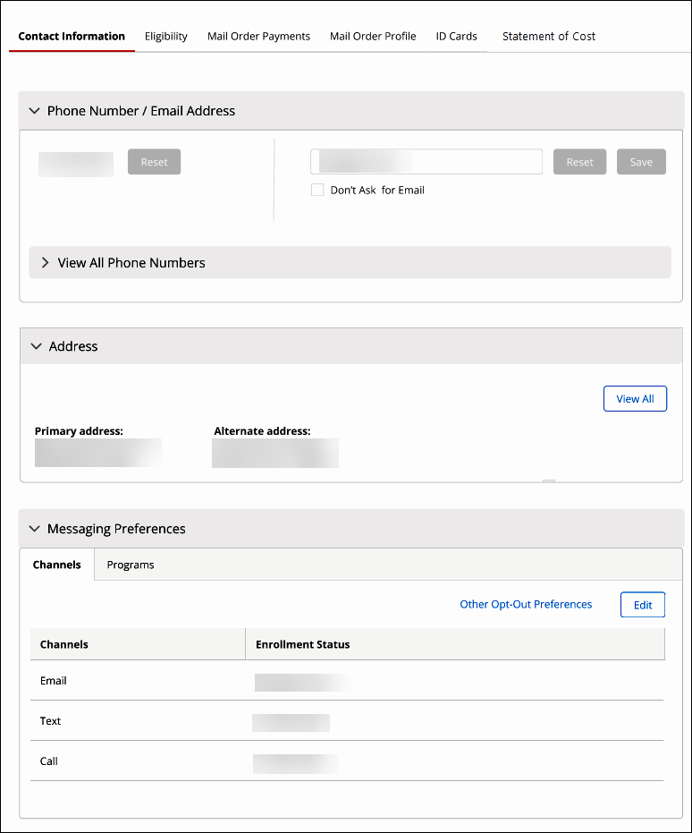

|  |  |
| --- | --- |
| **Section/Field** | **Details** |
| **Phone Number/ Email Address** | Displays the current phone number and email address of the member.   * Reset button allows both the Phone Number and Email Address to be reset. * The “phone icon with the slash in the middle” likely indicates that the phone number is invalid or no longer in service. When this icon appears, the **agent must go to the specific row** in the system and select **‘Reset’** from the **row-level action menu**. After resetting, the **agent should ask the member if the invalid phone number should be deleted or removed.**      * Save button will save any changes made to the Phone Number or Email Address fields. |
| **Address** | Displays the Primary Address and Alternate address of the member. The View All button displays any additional addresses that the member has on file in a new Address tab. |
| **Messaging Preferences** | Displays **Channels** the member may receive messages through Email, Text or Call.  Displays **Programs** that are available to the member (**Example:** Full Drug Name).   * Edit button allows edits to Channels and Programs. * Other Opt-Out Preferences to Channels and Programs. |

**Eligibility**

The **Eligibility** tab contains the following collapsible sections and features:

* Additional Eligibility Details
* Group Coverage Details
* Other Insurer’s Information
* Grace Period Eligibility Audit Trail
* Back to the Top Chevron Arrow

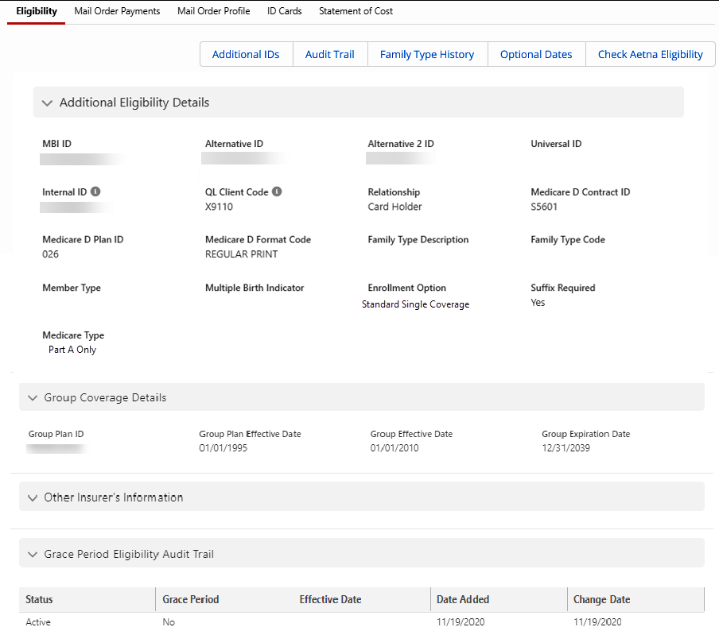

**Additional Eligibility Details**

|  |  |
| --- | --- |
| **Section/Field** | **Details** |
| **MBI ID** | Unique Medicare Beneficiary Identifier assigned by CMS (replaced HICN ID).  **Notes:**   * Should be secondary authenticator. * Only applicable to Medicare accounts. |
| **Alternative ID** | Alternate ID on the prescription drug card.  Alternate ID is normally supplied by the client or their eligibility vendor (or CMS if Med D). |
| **Alternative 2 ID** | Secondary Alternative ID. |
| **Universal ID** | An internal reference number is used to track a member’s claims from carrier to carrier. |
| **Internal ID** | An internal reference number used to track important information within a member’s account.  **Tip:** This is the member’s QL internal ID and is not exposed to our members, internal use only. |
| **QL Client Code** | Quantum Leap Client Code.  **Tip:** This is the clients QL Client Code and is not exposed to our members, Internal use only. |
| **Relationship** | Indicates relationship to the member. |
| **Medicare D Contract ID** | Indicates the type of Medicare D plan.  **Note:** Only applicable to Medicare accounts. |
| **Medicare D Plan ID** | Indicates the member’s Medicare D plan ID displayed on ID card.  **Note:** Only applicable to Medicare accounts. |
| **Medicare D Format Code** | Indicates language preference.  **Note:** Only applicable to Medicare accounts. |
| **Family Type Description** | Search criteria used to retrieve accumulators at a family level.  This field should not be used for High-Deductible Health plans.  **Note:** Not applicable to Medicare accounts. |
| **Family Type Code** | A code that describes plan coverage. |
| **Member Type** | Indicates the relationship of the selected member to the plan member. |
| **Multiple Birth Indicator** | Indicates if multiple births are associated with selected member. |
| **Enrollment Option** | Indicates the type of coverage where the member is enrolled. |
| **Suffix Required** | Special coding that controls the suffix assignment for plan members and their dependents. Exp; Primary cardholder is either 00 or 01, the spouse 02, and the dependents 03, 04, etc. |
| **Medicare Type** | Indicates the type of Medicare coverage.  **Note:** Only applicable to Medicare accounts. |

**Group Coverage Details**

|  |  |
| --- | --- |
| **Section/Field** | **Details** |
| **Group Plan ID** | Indicates the coverage Plan ID. |
| **Group Plan Effective Date** | Indicates the coverage of the Group Plan Effective Date. |
| **Group Effective Date** | Indicates the coverage Group Effective Date. |
| **Group Expiration Date** | Indicates the coverage Group Termination Date. |

**Other Insurer’s Information**

|  |  |
| --- | --- |
| **Section/Field** | **Details** |
| **Sequence Number** | Not applicable. |
| **Name** | Plan Name. |
| **Phone Number** | Plan Phone Number. |
| **ID Number** | Members other coverage ID number. |
| **PCN** | Coverage PCN number. |
| **BIN** | Coverage BIN number. |
| **Block Type** | Not applicable. |
| **Effective Date** | Coverage Effective Date. |
| **Expiration Date** | Coverage Expiration Date. |

**Grace Period Eligibility Audit Trail**

|  |  |
| --- | --- |
| **Section/Field** | **Details** |
| **Status** | Status (Active, Inactive). |
| **Grace Period** | Indicates if a member is in a grace period (Yes, No). |
| **Effective Date** | Date the grace period indicator began to display. |
| **Date Added** | Date the record was added to the member’s profile. |
| **Change Date** | Date the record was last modified. |

**Back to the Top Chevron Arrow**

|  |  |
| --- | --- |
| **Section/Field** | **Details** |
| **Eligibility tab**  **Mail Order Profile tab**  **Mail Order Payments tab** | The back to top chevron arrow (to the right and left of the panel) will allow agent to quickly navigate back to the top of the page without manually scrolling. |

The **Eligibility** tab also contains the following functions:

|  |  |
| --- | --- |
| **Functions** | **Details** |
| **Eligibility** | The **Eligibility** tabwill display Eligibility information. Access Eligibility functionalities from here. |
| **Additional IDs** | Allows to view **Additional IDs** on member’s account.     |
| **Audit Trail** | Allows view for any **Audits** on the member’s account. |
| **Family Type History** | Allows view for **Family Type History** on the member’s account. |
| **Optional Dates** | Allows view of **Optional Dates** on the member’s account. |
| **Check Aetna Eligibility** | Allows view of **Eligibility for Aetna** on the member’s account. |

**Mail Order Payments**

The **Mail Order Payments** tab contains the following collapsible sections:

* Card
* Electronic Check (eCheck)
* Alternative Payment Options

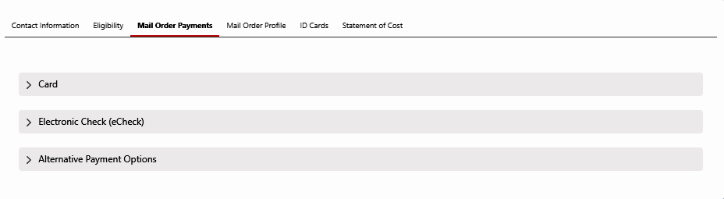

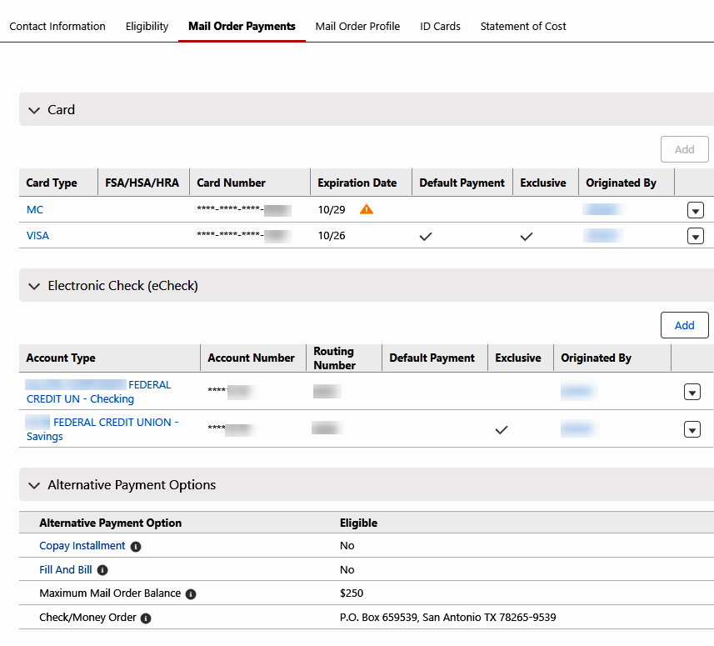

**Mail Order Payments tab**

|  |  |
| --- | --- |
| **Section/Field** | **Details** |
| **Caution** | Indicates the member has a card on file that has expired within the last 3 (three) months or is going to expire in the next 3 (three) months. |

**Card**

|  |  |
| --- | --- |
| **Section/Field** | **Details** |
| **Add** | Button allows addition of a Credit Card/Debit Card. |
| **Card Type** | Company carrier of the card. (**Examples:** Visa, Mastercard, etc.) |
| **FSA/HSA/HRA** | FSA, HSA, and HRA are savings accounts used to pay for qualified medical, prescription, dental, and vision expenses. |
| **Card Number** | Number assigned by the card carrier to identify the card. |
| **Expiration Date** | Date that the card expires. |
| **Default Payment** | Card the member has authorized to be used for all orders. |
| **Exclusive** | Card the member has authorized to be used **only** for themselves. |
| **Originated By** | Member that originally added the card or made the last update. |

**Electronic Check (eCheck)**

|  |  |
| --- | --- |
| **Section/Field** | **Details** |
| **Add** | Button allows addition of an Electronic Check (eCheck). |
| **Account Type** | Financial institution and whether it is a Savings or Checking account. |
| **Account Number** | Number thefinancial institution uses to identify the account. |
| **Routing Number** | 9-digit number used to identify the financial institution. |
| **Default Payment** | Account that the member has authorized to be used for all orders. |
| **Exclusive** | Account that the member has authorized to be used **only** for themselves. |
| **Originated By** | Member that originally added the account or made the last update. |

**Alternative Payment Option**

|  |  |
| --- | --- |
| **Section/Field** | **Details** |
| **Copay Installment** | Yes/No indicates whether the member is eligible for the Copay Installment Program.   * Tool Tip displays, “Allows a member to break up the total amount due for their prescription order into three equal payments.” |
| **Fill and Bill** | Yes/No indicates whether the member is eligible for the Fill and Bill Program.   * Tool Tip displays, “Allows the member to have a bill sent with their order, instead of paying up-front with an electronic method of payment or check/money order.” |
| **Maximum Mail Order Balance** | Maximum balance allowed if Client has Fill and Bill, or the maximum balance for new prescriptions sent in by provider shipped out as a courtesy if no payment on file.   * Tool Tip displays, “Maximum balance allowed if Client has Fill and Bill, or the maximum balance for new prescriptions sent in by provider shipped out as a courtesy if no payment on file.” |
| **Eligible** | Field displays an indicator (Yes/No) that the member is eligible to participate in the Alternative Payment Options. |
| **Check/Money Order** | Provides the address the member can mail payments to.   * Tool Tip displays, “Inform the member to include the invoice when mailing in their payment. Member should place their ID number on check/money order. Check/money order cannot be split between accounts; each account requires a separate check/money order.” |

**Mail Order Profile**

The **Mail Order Profile** tab contains the following collapsible sections:

* Mail Order Preferences
* Allergies
* Diagnoses

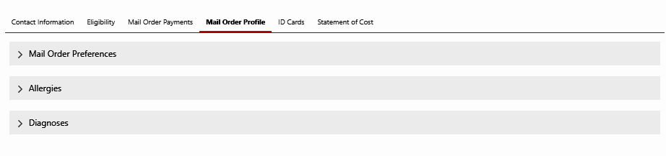

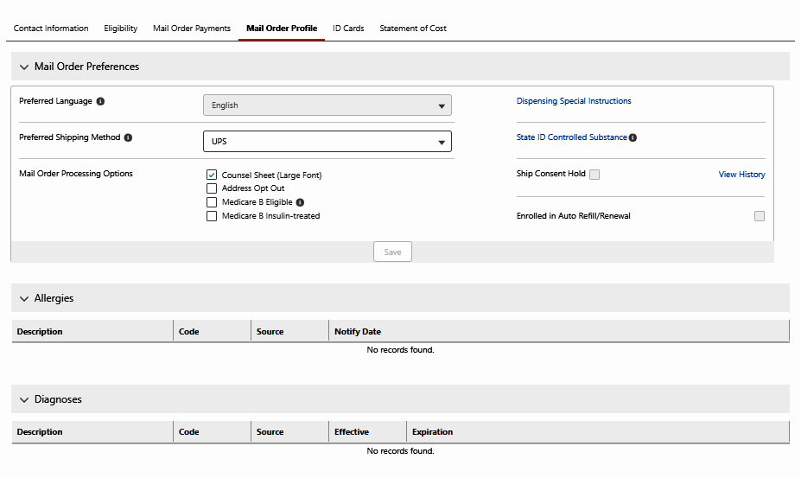

**Mail Order Preferences**

|  |  |
| --- | --- |
| **Section/Field** | **Details** |
| **Preferred Language** | Provides the option to select what language the member would like their prescription instructions dispensed. Disclaimer indicates no guarantee. |
| **Dispensing Special Instructions** | View or inquire about dispensing special instructions the member may have on their profile. |
| **Preferred Shipping Method** | Select the members preferred method of shipping for prescriptions. Disclaimer indicates no guarantee. |
| **State ID Controlled Substance** | When dispensing C2-C5 drugs, laws may require a member to provide his or her Social Security number, driver’s license, or state ID. |
| **Mail Order Processing Options** | View or update any of the following: Counsel Sheet (Large Font), Address Opt Out, Medicare B Eligible, or Medicare B Insulin-treated.  **Note:** Next to the **Medicare B Eligible** checkbox is the following:  **Tip:** “Opts member out of Auto-Refill/Renewal program.”   * If Medicare B Eligible is checked, a Medicare B Eligible popup will display with the following confirmation message: “If member is enrolled in a Medicare B plan, all of their prescriptions will be opted out of the Auto-Refill and Auto-Renewal (ARR) program. Are you sure you want to indicate that the member is Medicare B Eligible?” |
| **Ship Consent Hold** | * If ship consent is checked, member is required to give ship consent. * If unchecked, member has opted out and ship consent is not required. (View History shows SCH reason, effective and expiration dates, modified by and date modified.) |
| **Enrolled in Auto Refill/Renewal** | It is checked if member has any medication(s) enrolled in Automatic Refill and/or Automatic Renewal Program. |

**Allergies**

|  |  |
| --- | --- |
| **Section/Field** | **Details** |
| **Description** | Details the type of allergies we have recorded for the member in our database. |
| **Code** | Medical coding associated with the allergy. |
| **Source** | Where the allergy information originated from. |
| **Notify Date** | Date we were notified of the allergies by the source. |

**Diagnosis**

|  |  |
| --- | --- |
| **Section/Field** | **Details** |
| **Description** | Details the type of diagnosis we have recorded for the member in our database. |
| **Code** | Medical coding associated with the diagnosis. |
| **Source** | Where the diagnosis information originated. |
| **Effective** | Date the diagnosis was effective in our database. |
| **Expiration** | Date the diagnosis will expire in our database. |

**ID Cards**

The **ID Cards** tab contains the following collapsible sections:

* Member(s)

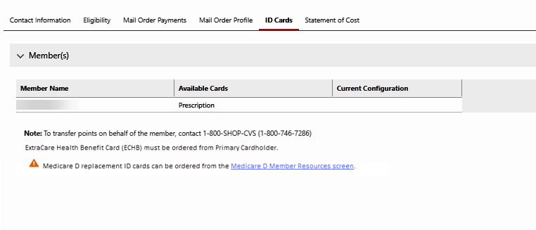

**Member(s)**

|  |  |
| --- | --- |
| **Section/Field** | **Details** |
| **Member Name** | Indicates member’s name. |
| **Available Cards** | Indicates the type of cards available to be sent to the Member. (**Prescription** or **ExtraCare Health Benefit Card**) |
| **Current Configuration** | Indicates the delivery method used to send and receive ID Cards. |
| **Note** | Indicates the action the member needs to take, if transferring points; to transfer points on behalf of the member, contact 1-800-SHOP-CVS (1-800-746-7286). |
| **Additional Messages** | ExtraCare Health Benefit Card (ECHB) must be ordered from Primary Cardholder.  **Med D Only:** A hyperlink is provided to order replacement ID Cards from the Medicare D Member Resources screen. |

**Statement of Cost**

The **Statement of Cost** tab contains the following collapsible sections:

* Annual Statement of Cost
* Generate Statement of Cost
* History

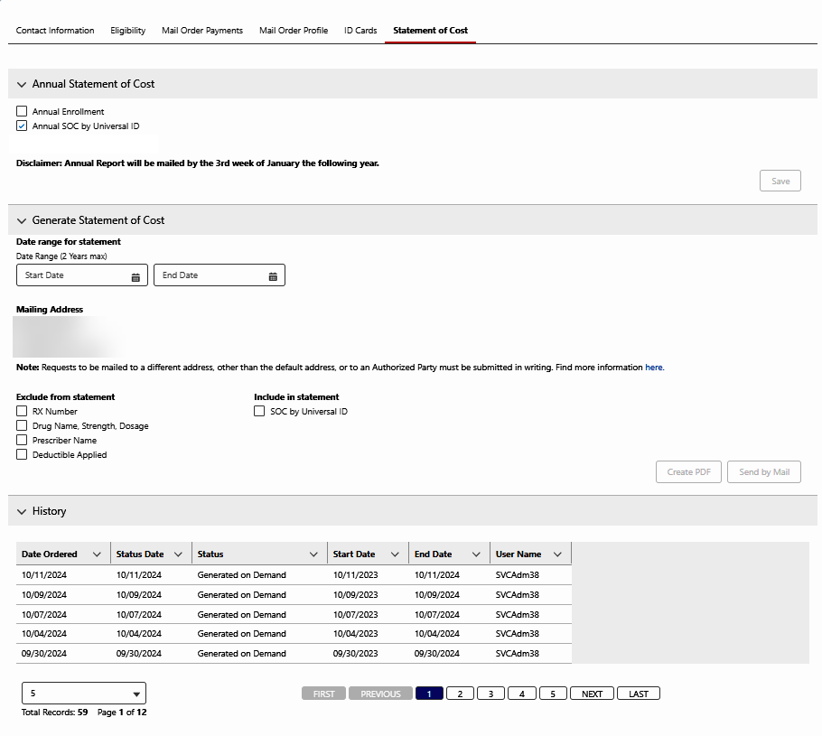

**Annual Statement of Cost**

|  |  |
| --- | --- |
| **Section/Field** | **Details** |
| **Annual Enrollment** | View or Update the member’s enrollment for an Annual Statement of Cost. |
| **Annual Statement of Cost by UID** | View or Update the member’s enrollment for an Annual Statement of Cost by Universal ID. (This ensures that all claims processed with this ID will be pulled, regardless of carrier-to-carrier changes.) |
| **Disclaimer** | Indicates the Annual Report will be mailed by the 3rd week of January the following year. |
| **Save button** | Used to save any changes to Annual Enrollment updates. |

**Generate Statement of Cost**

|  |  |
| --- | --- |
| **Section/Field** | **Details** |
| **Date Range for Statement Enrollment** | Indicates the date range the member requests for the SOC. “Start Date" and "End Date.” (Fields will require MM/DD/YYYY and allow for standard calendar picklist.) |
| **Mailing Address** | Provides the default Mailing Address on file Statement of Cost will be mailed to. |
| **Note** | Requests to be mailed to a different address, other than the default address, or to an Authorized Party must be submitted in writing. (**Find more information here** hyperlink will take the agent to the work instructions based on client.) |
| **Exclude from Statement** | View or Update any of the following: RX Number, Drug Name, Strength, Dosage, Prescriber Name or Deductible Applied |
| **Include in Statement** | View or Update the following: Statement of Cost by Universal ID |
| **Create PDF button** | Button will display the Statement of Cost as a PDF. |
| **Send by Mail button** | Button is used to submit the Statement of Cost by Mail. |

**History**

|  |  |
| --- | --- |
| **Section/Field** | **Details** |
| **Date Ordered** | Date the Statement of Cost was ordered. |
| **Status Date** | Date the item/order was last updated. |
| **Status** | Status of the Statement of Cost: Submitted, Printed, Generated on Demand. |
| **Start Date** | Start Date field used to generate the Statement of Cost. |
| **End Date** | End Date field used to generate the Statement of Cost. |
| **User Name** | Compass user’s name who generated the Statement of Cost. |

Top of the Document

|  |
| --- |
| Quick Actions |

This section contains the following **quick actions** that will open a new tab for access to additional member plan details.

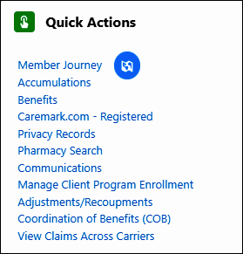

|  |  |
| --- | --- |
| **Section/Field** | **Details** |
| **Member Journey** | Used to view all interaction history for actions taken for the member. |
| **Accumulations** | Shows the deductible and out of pocket limits along with current accumulations. |
| **Benefits** | If client plan design information has been provided, you will find it here.  **Example:** Copay information |
| **Caremark.com – Registered / Not Registered** | Used to send the member a Quick Registration link for Caremark.com. |
| **Privacy Records** | Indicates the documents of the party authorized to act on behalf of the member. |
| **Pharmacy Search** | Used to search for pharmacies agreeable to the caller. |
| **Communications** | Used to view communications the member has received. |
| **Manage Client Program Enrollment** | Used to Opt In/Opt Out members from the Cost Saver Program(s). (The client must be enrolled in the Cost Saver Program for the hyperlink to display.) |
| **Adjustments/Recoupments** | Used to determine if there is an amount owed on a terminated member’s account due to a payment the plan made after the date coverage was terminated. |
| **Coordination of Benefits (COB)** | Shows the member's (active/inactive) COB information, alternate insurance, and manufacturer copay assistance. |
| **View Claims Across Carriers** | Used to view claims using this ID and track a member’s claims from carrier to carrier. |

Top of the Document

|  |
| --- |
| Medicare D Quick Actions |

 If the account is not MED D/EGWP, Medicare D functionality will NOT display. Refer to Quick Actions instead.

This section contains the following Med D **quick actions** that will open a new tab for access to additional member plan details.

|  |  |
| --- | --- |
| **Section/Field** | **Description** |
| **Submit Grievance** | Used to submit Grievances for Medicare D Members. (Client Specific and hyperlink displays only if client allows submission of grievances.) |
| **View Previously Submitted Grievances** | Used to view Grievance History. (Client Specific and hyperlink displays only if client allows submission of grievances.) |
| **Stars Central Portal** | Stars Central Portal (SCP) Tool is used to compare Individual plan details and assist beneficiaries with questions. (Displays for Med D Members only.) |
| **Medicare Prescription Payment Plan (M3P)** | Used to access the Medicare Prescription Payment Plan (M3P) tab.  **Note:** Medicare Prescription Payment Plan program is abbreviated as MPPP by CMS and may be known by members as MPPP. At this time, the program is referred to as M3P in the Compass system. |

Top of the Document

|  |
| --- |
| Opportunities |

The Opportunities panel contains the **opportunities** that are available to the member.

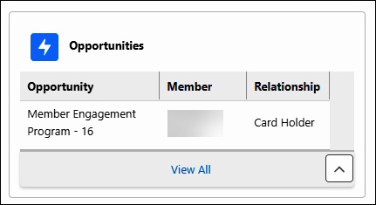

|  |  |
| --- | --- |
| **Section/Field** | **Details** |
| **Opportunity** | Opportunity available to the member. |
| **Member** | Member’s name. |
| **Relationship** | Member’s relationship to the cardholder. |

Top of the Document

|  |
| --- |
| Member’s Recent Cases |

The **Member’s Recent Cases** panel shows the members’ most recent cases.

**Note:** The icons in the screenshot below indicate the method of contact: Voice engagement , Email engagement, and Chat; additionally, by clicking on View All Cases, you can find the same information in text format under the Case Origin column.

|  |  |
| --- | --- |
| **Section/Field** | **Details** |
| **Case Number** | Record ID of an Interaction or Research Case. The Case Number displays the details of the resolution from previous Interaction or Research Cases. |
| **Reason** | Primary Interaction Reason for the case. |
| **Status** | Status of the case: Open, Closed. |
| **Type** | Type of case that was opened: Interaction, Research. |
| **Date/Time Opened** | Date/time the case was opened. |
| **View All Cases** | Used to review all previous cases on the member’s account. |
| **View PeopleSafe Activity** | Used to review auto-populated notes, documentation, and task information from previous calls that were made in PeopleSafe. |
| **View All Family Cases** | Used to review Family cases shown on Member Journey screen. |
| **View Enterprise Interactions** | Used to view detailed information about an interaction, including the date, time, channel (phone, web, etc.) and the type of activity performed. |

Top of the Document

|  |
| --- |
| Medicare D Member Snapshot |

 If the account is not MED D/EGWP, the Medicare D Landing Page and other Medicare D functionality will NOT display. Refer to Member Snapshot instead.

**Description:** Outlines Member Snapshot Landing Page for Medicare D Members and functionality found in Compass.

Each panel on the Member Snapshot Landing Page can house individual components that may require scroll bar use. When using the panel scroll bar, scrolling is dynamic. Refer to [Compass - Optimize the On-screen Experience (049985)](https://thesource.cvshealth.com/nuxeo/thesource/#!/view?docid=2f702dca-38c5-4b46-be0b-8191ed5619e1) for more details.

The Medicare D Member Snapshot Landing Page contains the following components:

1. Case Data
2. Alerts
3. Member Details
4. Client and Processing Information
5. Center Panel
   * Contact Information
   * Eligibility
   * Mail Order Payments
   * Mail Order Profile
   * ID Cards
   * Statement of Cost
6. Quick Actions
7. Opportunities
8. Member’s Recent Cases

The **Medicare D** tab will **not** display if:

* Member is not a MED D Member.
* Agent is viewing Secondary Coverage.
* Member is a Medicare D Member and is a Client Pharmacy Member.
* Member is not a Client Pharmacy Member and not found in FACETS.
* Medicare D Member, not a Client Pharmacy Member, and a system error occurs calling FACETS.



**Note:** When accessing the Member Snapshot Landing Page for a Medicare D beneficiary with multiple lines of eligibility, the following banner will display under the **Case Data** panel: “You are currently viewing <active/inactive> eligibility in carrier <Carrier> in Member Snapshot. The Medicare D Line of Eligibility selected is <active/inactive> line of eligibility for carrier <Carrier>.”

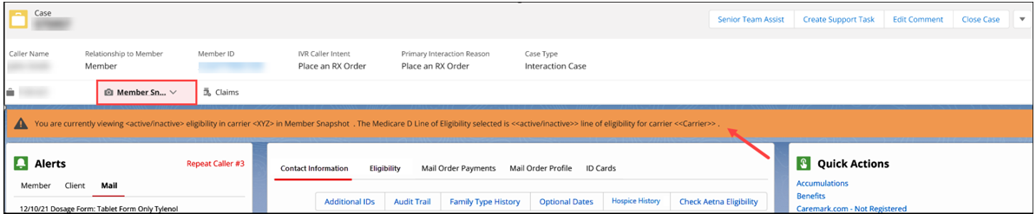

Top of the Document

|  |
| --- |
| Related Documents |

**Parent Document:**  [CALL-0049 Customer Care Internal and External Call Handling](https://policy.corp.cvscaremark.com/pnp/faces/DocRenderer?documentId=CALL-0049)

Top of the Document

Not to Be Reproduced or Disclosed to Others without Prior Written Approval

**ELECTRONIC DATA = OFFICIAL VERSION / PAPER COPY = INFORMATIONAL ONLY**